|  |
| --- |
|  |
|  |
| VDOT Office or Firm Name  City, State  Technical Discipline |

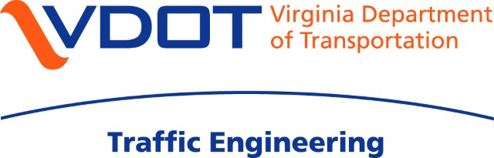

**LEFT-TURN PHASE SELECTION ENGINEERING ASSESSMENT WORKBOOK**

**Intersection Information**

|  |  |
| --- | --- |
| *Intersection: Click here to enter text. | |
| *Operations Region: Choose a Region | *Locality: Click here to enter a locality |
| *Intersection Node: | *Reference #: |
| *Prepared by: | *Date: Click here to enter a date. |
| *Reviewed by: | *Date: Click here to enter a date. |
| *Assessment Origin:  New Signal Rebuild – Modification  Operations – Timing Study Other: | |

**Intersection Characteristics & Left-Turn Phasing Mode(s)**

|  |  |  |  |  |  |
| --- | --- | --- | --- | --- | --- |
|  | \***Speed Limit** | \***# of Exclusive LT Lanes** | \***# of Shared LT Lanes** | \***Existing LT Phasing:** | \*\*\*\***Proposed LT Phasing:** |
| NB Approach | N/A | 0 | 0 | Choose an item. | Choose an item. |
| SB Approach | N/A | 0 | 0 | Choose an item. | Choose an item. |
| EB Approach | N/A | 0 | 0 | Choose an item. | Choose an item. |
| WB Approach | N/A | 0 | 0 | Choose an item. | Choose an item. |

**Additional information (if necessary):**

\*\*\***Intersection Engineering Assessment**

Click here to enter text.

**APPROACH WORKSHEETS**

|  |  |  |
| --- | --- | --- |
| **1 | NB Approach Evaluation |  |
| **2 | SB Approach Evaluation |  |
| **3 | EB Approach Evaluation |  |
| **4 | WB Approach Evaluation |  |

**WORKBOOK INSTRUCTIONS**

